**INDEX**

|  |  |  |
| --- | --- | --- |
| **Sr.**  **No.** | **Particular** | **Page**  **No.** |
| 1. | INTRODUCTION   1. Motivation 2. Problem Statement 3. Purpose, Objectives, Goals | 4 - 6    4  5  6 |
| 2. | SYSTEM ANALYSIS   1. Existing System 2. Scope & limitation of existing system 3. Project Features 4. Requirement analysis    1. Functional requirement    2. Performance requirement    3. Security requirement | 7 – 11  8  9  10  11 |
| 3. | SYSTEM DESIGN   1. Design Constraints 2. System Model (UML DIAGRAMS) 3. Data Model (ERD) 4. Data Model (DFD) 5. User Interface. | 12-25  12  13-17  18-19  20-21  22-25 |
| 4. | IMPLEMENTATION DETAIL   1. Software and hardware specification | 26 |
|  |  |  |

|  |  |  |
| --- | --- | --- |
| 5. | FUTURE SCOPE | 27 |
| 6. | CONCLUSION | 28 |
| 7. | BIBILOGRAPHY AND REFERANCE | 29 |

# Abstract:

Online pharmacy is website & User can post requirement for medicine. User can purchase medicine online. Prescription is mandatory for ordering medicine. As per prescription user can search medicine and useful information. This site can provide information for daily consumption of medicine. This application provides pre-information of the medicine. This application provides logins to the users. They can maintain their account.

# 1. INTRODUCTION

**A. Motivation**

E-Pharmacy provides medicines with a different types to order and sell regardless of where customer and seller use to buy and sell medicines that are available. In e-Pharamacy environment, customers are able to buy a medicines in good manner also seller use to sell his/her medicines on the site for a businesss purpose. this shows that the use of interactive features of e-pharma increases the communication which is in online mode. Internet technologies provide integrated

environment for web-based purchasing and selling to delivery push.

**B. Problem Statements**

1. Receipt generation problem**.**
2. Lack of Image of user and seller.
3. Online payment method is not available.

# C. Purpose, Object, Goal:

This is a very useful website for the pharmacist/seller, which reduces the work load and it will help you to manage all of the components of the pharmacy, such as Drug Administration, Orders etc., etc. that is, the increase in the efficiency of processing. In a pharmacy, and the bill inspection is an essential process. In addition, the pharmacy management system that you can easily serve as the requirements for the products. This includes the safe and secure storage of the medicinal product details, as well as a quick search, updating of products. The pharmacy management system is developed in order to ensure effective and clear the data storage and manipulation, and precision and medical products. The pharmacy management system is a easy-to use, so that the user can run a pharmacy without ambiguity. This is the project subject to a pharmacy management system with a high degree of minimisation of time and resources, and with the help of that by looking at the drug information, you can use the data in the shortest amount of time possible. The main objectives of this site are the automation of pharmacy organisations in the creation of a good quality by minimizing or eliminating the time of the loss.

# 2. SYSTEM ANYLISIS

It is the most creative and challenging phase of the system life cycle. The analysis phase is used to design the logical model of the system whereas the design phase is used to design the physical model.

Many things are to be done in this phase .we began the designing process by identifying forms, reports and the other outputs the system will produce. Then the specify data on each were pinpointed. we sketched the forms or say, the displays, as expected to appear, on paper, so it serves as model for the project to began finally we design the form on computer display, using one of the automated system design tool, that is Eclipse IDE.

Output design means what should be the format for presenting the results. It should be in most convenient and attractive format for the user. The input design deals with what should be the input to the system and thus prepare the input format. File design deals with how the data has to be stored on physical devices.

1. **Existing System.**

Currently, the medical works are based on the manual process, and each work is maintained in the paper. The details of purchasing drugs, audits, sell reports maintained on the paper while anyone can enter into the system and can make changes in these reports, so it is not a safe method to keep the information on the paper. The pharmacist faces problem in searching the products from the self as it is not an easy method to remember about the place of each medicine. There no Pharmacy Management System which can alert the pharmacist about the end of the drugs.

## **Proposed system :**

The design of the pharmacy management system is based on the computer which will simplify the maintenance of the information, accessible and efficient. The Pharmacy Management System will provide the information about the end of the drugs in the medical so that the physician can order them drugs before the end. The pharmacist and nurses will get more accurate results at the time sell, about the details of the use of medicines and the dosages so that the system will become more reliable to use than the present system. The records of each work will be secure as to access the information the user must have to provide the ID and password in the system

# Existing System Scope

Pharmacy management system is a management system that has been developed to improve the accuracy and increase the safety and efficiency of the pharmacy store. It has been one of the IT-systems, which helps pharmacists improve the supply, cost, health, safety, security, etc., etc. the management of the inventory and the sales activities, so as the user, so that the production dates, and due dates to individual products, or medications. Expiration date is the date of retail purchase, with the remaining amount of drug in the place of the drug in the pharmacy.We have a complete order system, a system for the registration of orders in the system for your business, and pharmacy stores. An order is a system for the customers, sellers.

# Existing System Limitations:

1. Whenever customer or seller wants to purchase or sell product , he/ she always need to give credential to the website for ex. Email address, mobile no. etc.
2. Whenever new user is wanted to visit a website and only wants to see available products he/she cannot see availability of the product without logging in inside website.
3. Lack of Buy Receipt of product to the customer.

# Project Features

1. Anytime, anywhere, anyone can use the e- pharmacy management system.
2. Easy to use & Effective communication between modules of site.
3. Personalized view, the content riches directly to the customer as rather than addressing.
4. Self registration , online customer can purchase the product and seller also can sell his/her medicines.

# Requirement Analysis:

Much of the initial focus of the research has been on website of e-pharmacy management. However, recently the hardware and the technology of delivering have been getting more attention in the form of Pharmacy Management. Researchers seem to agree that the use of tablets has potential that is underutilized in academia.the team reviewed publications of experiments on the use of tablets in higher education identifying some key findings. From these findings, the team has developed system requirements for the design of a purpose-built educational tablet for higher education.these findings include selecting tablets that would mirror the institution's own computer lab designs, including the operating system, educational applications, as well as restricting use of camera and restricting download of none- educational applications and apps.

# 3. SYSTEM DESIGN

1. **Design constraints:**

This project is concerned with the analysis, design, development, implementation and evaluation of an e- pharmacy management system to provide a user friendly environment for prospective customer and seller to buy and sell medicines and to fill bridge the gap between seller and customer.

# System Model (UML DIAGRAMS)

1. **Use Case Diagram :**

**Customer**

**ADMIN**

**Seller**

**2. Class Diagram**

Admin

Name

Phone Number

Email Address

User Name

Password

Manage Customers()

Manage Sellers()

Stock Reports()

Seller

Name

Phone Number

Email Address

User Name

Password

Stock Report ()

Update()

Delete()

Order()

Customer

Name

Phone Number

Email Address

User Name

Password

Order ()

Update()

Delete()

addmedicine()

f

Available stock

ID

Medicine Name

Seller Name

Quantity

Unit Price

Restock ()

Delete()

Order

ID

Medicine Name

Price

Quantity

Unit Price

**3. Activity Diagram for ADMIN**

Start

Admin is registered

Admin

login ID and Password

Check login id and password

Wrong Credential

Manage Medicines

Perform Actions

End

**Activity diagram for CUSTOMER**

Start

Cust. is registered

customer

login ID and Password

Check login id and password

Wrong Credential

Find the Medicine(s)

Orders Medicine

End

**Activity Diagram for Seller**

Start

Seller is registered

Seller

login ID and Password

Check login id and password

Wrong Credential

Manage Medicines

Checks orders

End

1. **Sequence Diagram**

Admin

Inventory Mngt

Stock Mngt

Medicine mngt

Login page

Add/edit Add/edit

Medicine stock

Save/update save/update

Medicine stock

Manage Medicine details List/Delete list/delete

Medicine stock

Manage Stock Details

Manage Inventory Details

Sequence diagram for E- Pharamcy Management

**B. Entity Relationship Diagram**

1

Admin

Manage

Purchased by

Sold By

M

customer

1 M M 1

Seller

Medicines

1. **Data Model (DFD):**

Inventory Management

Sells

Management

Medicines Management

Stock Management

Zero level DFD – E Pharmacy Management

Medicines Management

Generate Medicine Report

Stock Management

Check Stock Repot

Sells Management

Check Sells Report

Inventory Management

Generate Inventory Report

First level DFD – E Pharmacy Management

1. **User Interface:**

User interface (UI) design of e-pharmacy is a point of interaction between user and seller.

Users prefer more attractive and simpler interface designs rather than dull or complex designs. this study aims to outline the impact of UI design on the satisfaction of vi

**Screenshots of the User Interface**

**HOME PAGE :**

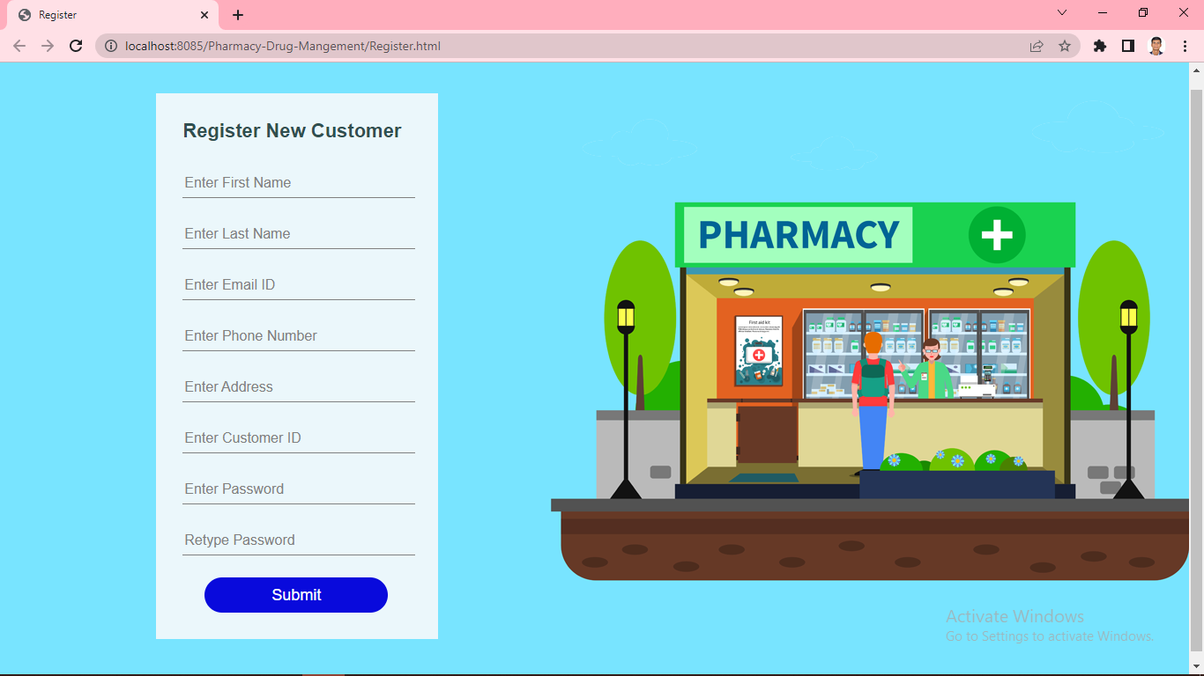

**LOGIN PAGE :**

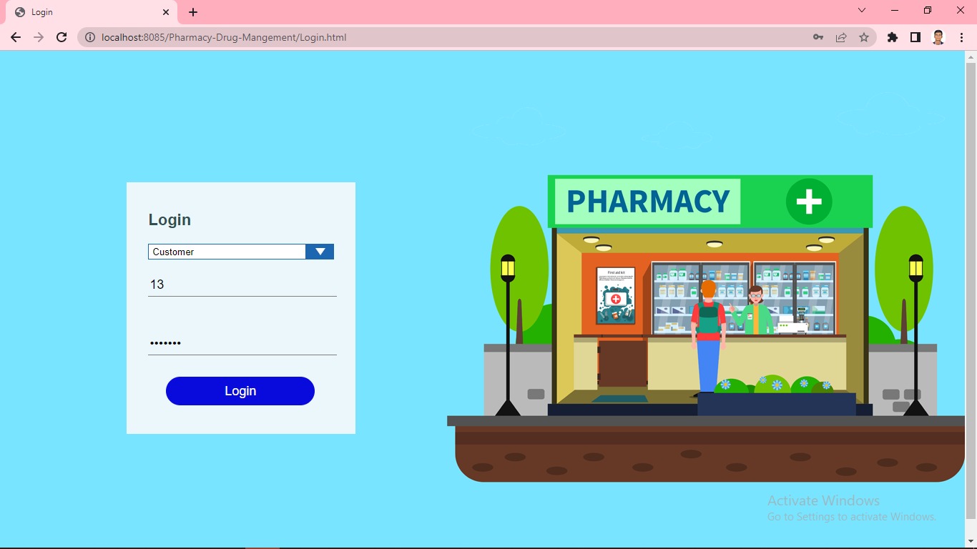

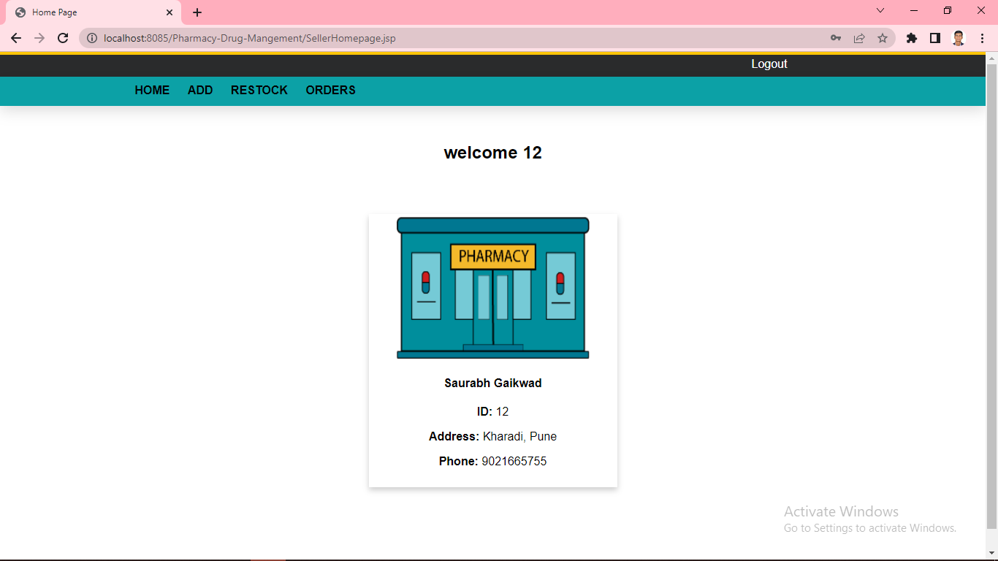

**AVAILABLE MEDICINES :**

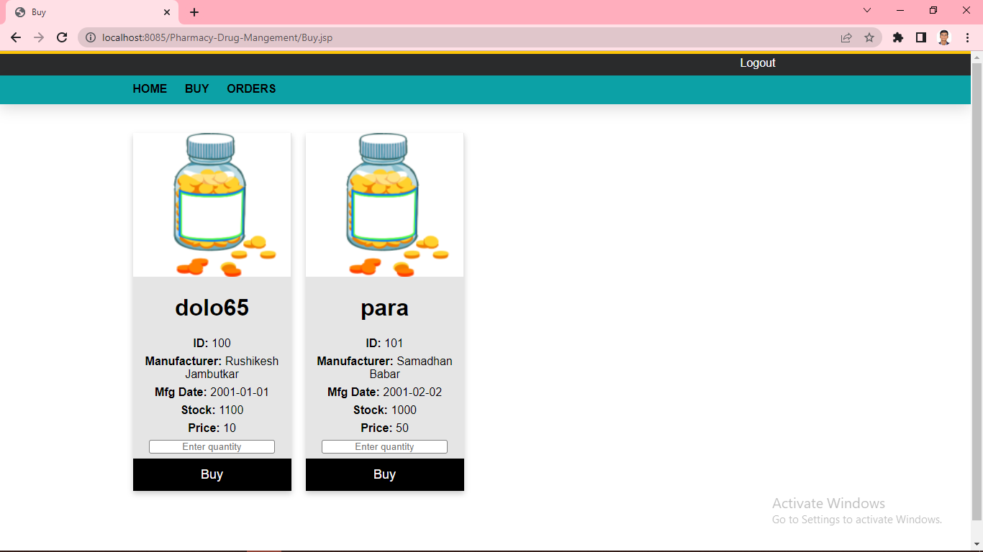

**SELLER ADD PRODUCT. :**

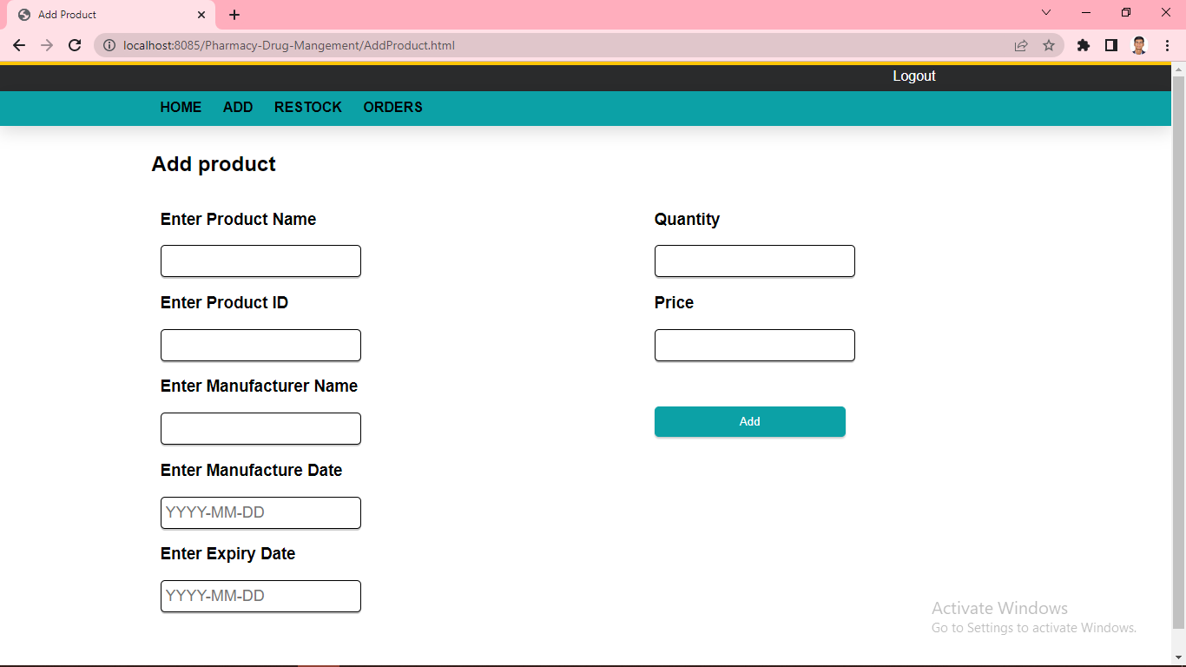

# IMPLEMENTATION DETAILS

1. **HARDWARE AND SOFTWARE SPECIFICATION:**
2. **SOFTWARE SPECIFICATION**

**Operating system:** Microsoft windows 2011.

**Frontend:** html, css, javascript

**Backend:** Java(JSP) JDK 1.8

**Database:** MySql 8.0

**Browser :** Google Chrome

**Connectivity :** Internet

**Server :** Apache Tomcat server 9.0

# II. HARDWARE SPECIFICATION:

**Processer:** HP i3 4th gen. 1ghz.

**Hard disk:** Minimum 5GB

**RAM:** 2.00 GB

# FUTURE ENHANCEMENT

1. Customer will get a receipt of bill after an order
2. More efficient User interface with more drug management will be conducted.
3. Sponsorship and advertisement will be played on site after hosting on internet.
4. Transaction management and record keeping will be more
5. E-pharmacy management has a great scope in the future as well. It is a well-known fact that the purpose of medicines buy and sell. With the help of online website, the masses have been able to access in expensive product, and save time, money and energy.
6. Earlier there was a misconception that medicines are not genuine or comes wrong in hand but nowadays in this technology era everyone uses internet and has started believing the internet and it’s online shopping and shipping and it will be exceeded further more.

# CONCLUSION

To improve the safety and efficiency of the pharmacy, retail store, to foster the improvement of the pharmacy management system. In this case, we have a project that is on a computer, based on the type of the system. This will help you to improve the administration of a medicine's cost, security. Pharmacy management system has been created in order to ensure the reliability of the customers. They are to be able to make the sale of the right to medicines, together with access to them, which will reduce the amount of these criminal activities. Pharmacy management system is basically an internetbased site and processes the required data , as well as information regarding the pharmacy database management. The site helps you to manage your shop online or in-store efficiency. Statistics drugs, medicines, or medicines to control the data that may be updated and edited as well. It works the needs of the user, and the corresponding options. It is up to the user to perform the production ,and if the expiry date of the medicinal product is out of stock, and the purchase and sale transaction., etc. There are many other features available to you. The most important goal of it is to be maintained, and the management of the pharmacy data efficiently and easily.

# BIBLIOGRAPHY

# During the development of E-Pharmacy Management

# project, We have gone through the following books

# and websites.

# Books:-

# Core Java, Advance Java,

# Web Technology, DBMS.

# Websites:-

# [www.w3schools.com](http://www.w3schools.com)

# [www.geeksforgeeks.com](http://www.geeksforgeeks.com)

[www.javatpoint.com](http://www.javatpoint.com)

[www.youtube.com](http://www.youtube.com)

**Thank You.**